AI StudyBuddy
Project Planning
Planning Phase

Project | AI StudyBuddy
Project ID | SWTID-2026-7764
Prepared | 28 September 2026
Source | Current source folders: backend/ and client/
Document status | Project-specific draft based on current backend/client source evidence

Document Contents
- Backlog and Sprint Planning
- Dependency Flow
- Planning Risks

Backlog and Sprint Planning
The following plan is a proposed baseline derived from the implemented modules. Completion values are intentionally not fabricated; the team should update them after execution.
Sprint | Epic | Story | Story points | Priority
Sprint 1 | Foundation and authentication | As a student, I can register, log in, and reach the dashboard. | 5 | High
Sprint 1 | Foundation and authentication | As the system, I can protect material routes with JWT. | 3 | High
Sprint 2 | Material workspace | As a student, I can upload and manage PDF/TXT/MD material. | 5 | High
Sprint 2 | Material workspace | As a student, I can view and filter my materials. | 3 | High
Sprint 3 | AI learning assets | As a student, I can generate a summary, flashcards, and a quiz. | 8 | High
Sprint 3 | AI learning assets | As a student, I can generate a study plan from material. | 3 | High
Sprint 4 | Practice and governance | As a student, I can complete a quiz and view feedback. | 5 | High
Sprint 4 | Administration | As an admin, I can view users/stats and remove a user with materials. | 5 | Medium
Sprint 5 | Persistence and hardening | As a user, my notes, tasks, and analytics persist across sessions. | 8 | Medium
Sprint 5 | Quality and release | As an operator, I can run tests, build, deploy, and monitor the system. | 8 | High

Dependency Flow
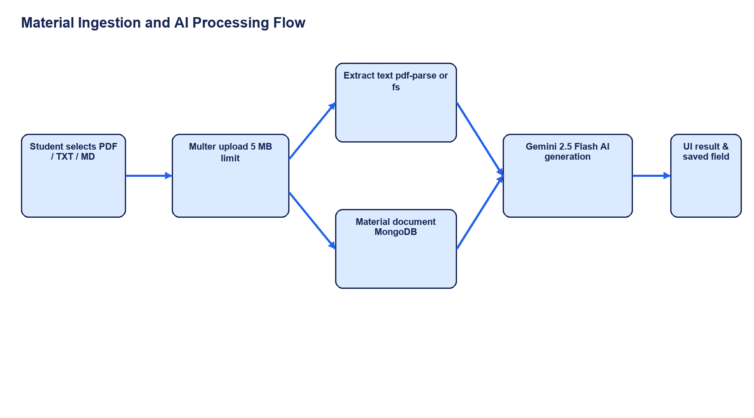
The implementation dependency flow: ingestion enables persistence, which enables AI generation and UI output.

Planning Risks
- Gemini availability and cost/quotas may affect AI stories.
- AI-generated structured JSON needs validation and failure handling.
- Local-only notes and planner state can create data loss across reloads; AI study plans are saved on Material documents.
- The requested AdminPanel is not found in the selected current client source and must be verified against the intended source.
- Public role registration is a security blocker until the server ignores or restricts client-supplied admin roles.
- No automated tests are currently configured in the backend package.

